AG NOTES
By John Teague
UT/TSU Extension
November 16, 2021

NOW IS THE TIME!
I always get calls and questions about killing that yellow weed in pastures and horse lots. This problem weed is wild buttercup, and it produces a bright yellow bloom in the spring. Most animals don’t eat it. It competes with other desirable grasses and it has no real value, unless you like yellow pastures and lots.
The rest of the year it is out of sight and out of mind. But it’s here now in abundance. This plant is a fall germinated weed, and it’s out there in the grass lots and pastures. And it is in the immature stage, and easy to kill with our good product 2,4-D.
Spray it now when you have temperatures above 60 degrees for three days. Just keep from spraying it when it’s windy.
I have attached a photo to help you identify it now. If you wait until it blooms, the plant is too mature, the leaves have produced a wax that seals themselves and the weed control products can’t penetrate into the plant to be very effective.
So, now is the time!

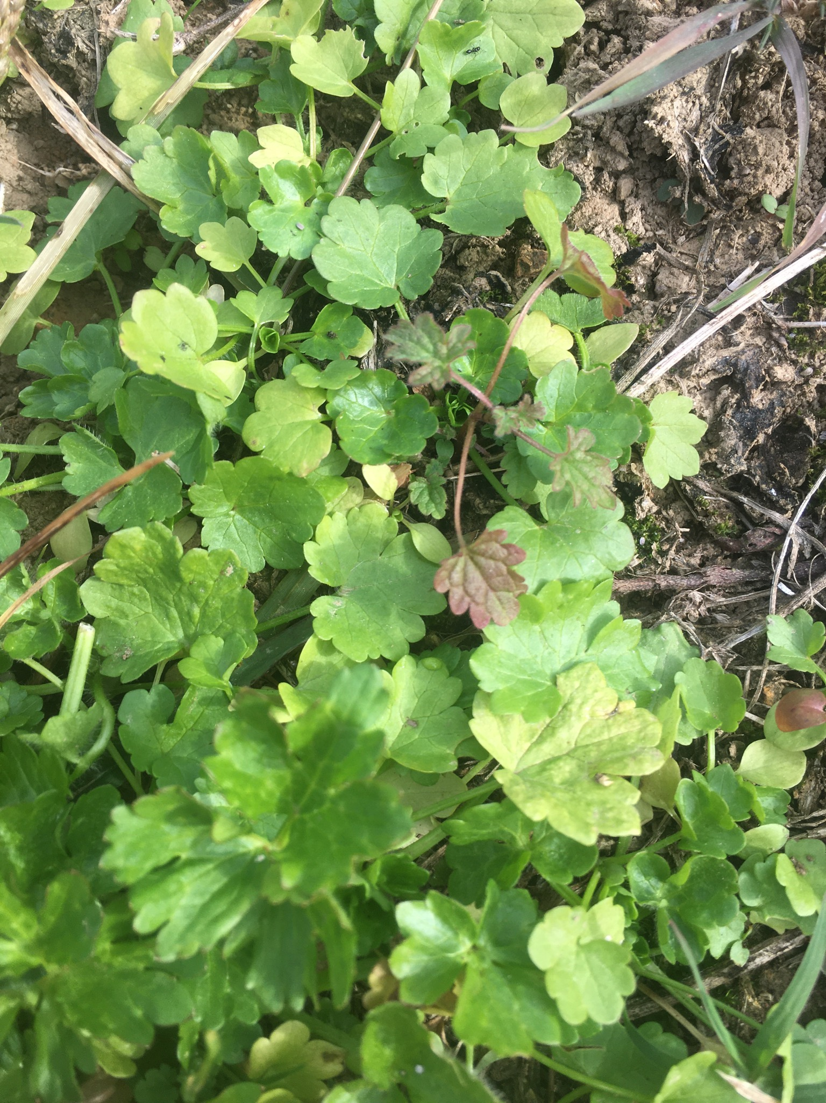
LADYBUGS
In Tennessee, the invasion has started. They start seeking shelter when we have our first freezes, which was a week ago. The Multicolored Asian lady beetles, orange-red with a variable number of spots, often invade homes in the search of a protected overwintering spot.
These beetles may congregate on the sunny sides of buildings by the thousands and, if given the opportunity, will often move inside. They look for vertical structures, which to them resemble cracks and crevices in nature. So, doors and windows are inviting to them.
Multicolored Asian lady beetles were first introduced into the U.S. to control aphids, and so are considered a beneficial insect. Black spots that form an “m” or “w” on the pronotum (area behind the head) and the square-shaped spots ranging in number from none to 19 help distinguish this species from other lady beetles.
Multicolored Asian lady beetles are considered extremely beneficial. These beetles do not sting, do not carry diseases and do not consume or excavate wood. However, they can stain wallpaper and upholstery yellow when crushed. When the multicolored Asian lady beetle is present in large numbers, some individuals with insect allergies have been irritated.
What can be done to prevent this beetle from entering your home? Exclude them! Don’t give them the chance to enter! Exclusion practices should be performed each year by September. But it is never too late during the invasion! The first step to prevent entry into a home is to seal cracks and crevices where insects may enter the structure. (Gaps 1/8 inch or so will allow entry into a home).
This includes caulking around window frames, fitting all outside doors with door sweeps, adding rubber bottom seals to garage doors and using foam weather-stripping under and around sliding glass and other doors. Utility openings into the structure, such as the gaps around outdoor faucets, gas meters, dryer vents, wires, etc. should be sealed.
Holes can be filled with caulking, cement, steel wool or copper mesh. An easy way to seal openings around pipes is to stuff steel wool or copper mesh into the opening and seal with expandable foam. Caulk should be applied around cracks in window framing, siding and other areas. Damaged window screens should be repaired. Insect screening may need to be installed behind attic and crawl space vents.
This information came from our UT publication Lady Beetles Invading Homes SP503-C. Look at it for more information on exclusion.

EQUIPMENT SALE
The popular equipment sale held for many years here at the Bedford County Ag Center will be held Saturday after Thanksgiving, November 27. Equipment will be received on Wednesday and Friday, November 24 and 26 prior to the sale date.
For more information, contact Bob Morton, 931-842-1234.

